DOMNULE PRIMAR

Cerere/declaraţie pe propria răspundere a titlarului de rol/membrului gospodăriei-exploatație agricolă/moștenitor acceptant

Subsemnatul/a _______________________________________, CNP__________________,

posesor/oare al/a BI/CI, seria___, nr.________, eliberat/a de SPCLEP ______________,domiciliat/ă în mun/oras/com_____________________________________,sat___________________________str.________________________, nr._______, bl______, sc._____, et._____, ap.____, jud._________,vă rog să-mi aprobati eliberarea unei adeverinte fiindu-mi necesara la APIA , din care să reiasă că sunt inregistrat in Registrul Agricol al comunei Stangaceaua si detin suprafata de teren_____________ ha .

În acest sens declar (**SUB SANCTIUNEA CODULUI PENAL** privind falsul în declarații) că utilizez următoarele suprafeţe de teren agricol:

**În proprietate:**

- suprafaţa ____________ha,

- suprafaţa ____________ha,

- suprafaţa ____________ha,

- suprafaţa ____________ha,

- suprafaţa ____________ha,

- suprafaţa ____________ha,

- suprafaţa ____________ha,

- suprafaţa ____________ha,

- suprafaţa ____________ha,

- suprafaţa ____________ha,

**În folosinţă :**

- suprafaţa ____________ha,

- suprafaţa ____________ha,

- suprafaţa ____________ha,

- suprafaţa ____________ha,

- suprafaţa ____________ha,

- suprafaţa ____________ha,

- suprafaţa ____________ha,

- suprafaţa ____________ha,

- suprafaţa ____________ha,

- suprafaţa ____________ha,

Terenul provine din urmatoarele documente: ____________________________________________________________________________________________________________________________________________________________________________________________________________________________________________________________________________________________________________________________________________________________________________________________________________________________________________________________________

__________________________________________________________________________________________________________________________________________________________________________________________________________________________________

Am luat la cunoştinţă că informaţiile din prezenta cerere vor fi prelucrate conform Regulamentului ( UE)2016/679 din 27 aprilie 2016 privind protecţia persoanelor fizice în ceea ce priveşte prelucrarea datelor cu caracter personal şi privind libera circulaţie a acestor date.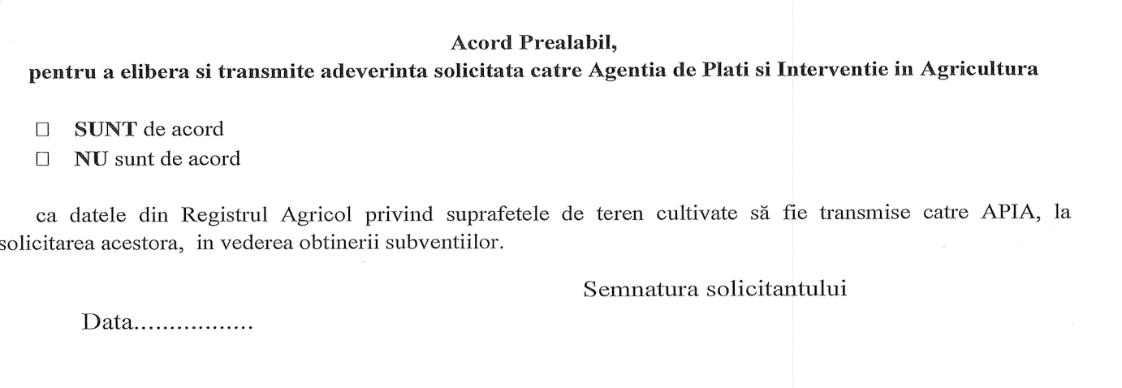

Dlui Primar al comunei Stangaceaua, judetul Mehedinti